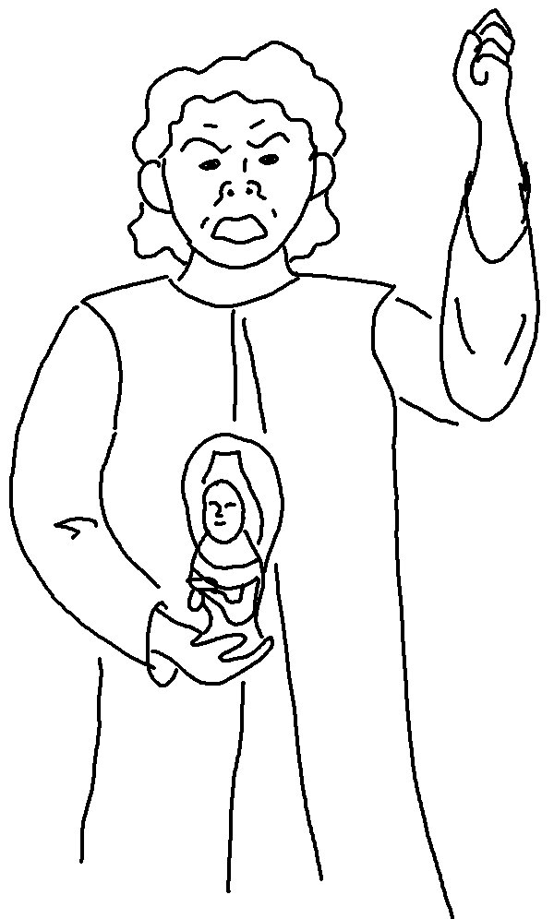
You must not make for yourself an _ _ _ _ of _ _ _ kind.
Exodus 20:4_{NLT}

